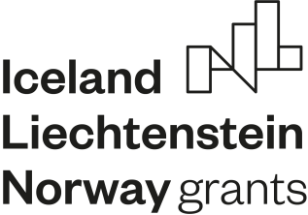
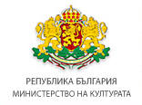
П Р О Г Р А М А
___________________________________________________________
„КУЛТУРНО ПРЕДПРИЕМАЧЕСТВО, НАСЛЕДСТВО
И СЪТРУДНИЧЕСТВО“

Call for project proposals under Outcome 2 “Access to Arts and Culture Improved”

Today, 2nd of September, 2019, the Ministry of Culture announced a call for project proposals under Outcome 2 “Access to Arts and Culture Improved” under the “Cultural Entrepreneurship, Heritage and Cooperation” Programme funded by the Financial Mechanism of the European Economic Area 2014-2021.
The Call will support project which create new artistic content through the organization of festivals, performances, traveling events, exhibitions, cultural routes and other. The events shall aim to attract and develop new audiences and to enhance the scope of cultural activity on the local and on the regional level.
The envisioned funds under the first call are 1 582 352 euros. The minimal amount that can be requested is 50 000 euros whereas the maximum one is 200 000 euros.
The deadline for submission of project proposal is 10.01.2020.
The guidelines for application and the accompanying documentation are published on the Information System of Management of the EU Funds (EUMIS 2020) on the following link: https://eumis2020.government.bg/bg/s/Procedure/Info/edb6005c-2b48-4e1f-9a8c-cc5f97d8cce2
More about the PA14 “Cultural Entrepreneurship, Heritage and Cooperation” Programme can be found here.
All the clarifications on submitted questions under the First Call under Outcome 2 “Access to Arts and Culture Improved” under the PA14 “Cultural Entrepreneurship, Heritage and Cooperation” Programme, funded by the EEA Grants, can be found here (by 23.12.2019).
The Financial Mechanism of the European Economic Area 2014-2021 provides funds given by Kingdom of Norway, Republic of Iceland and Principality of Liechtenstein. The aim is to reduce the economic and social disparities in Europe and to strengthen the bilateral relations between the Donor States and the Beneficiary States through funding of a couple of priority sectors (culture, civil society, good management, fundamental rights and freedoms).

